**Submitted by: Submitted to:**

**NAME: Rahul Gusain Dr. Hitesh Kumar Sharma**

**SAP: 500084143**

**ROLL NO.: R214220900**

**BATCH: 1 DevOps**

# Build and Release Management

**LAB EXERCISE 6**

**Aim:** Build Profile using Maven

**1)Building profile using eclipse IDE.**

**Step 1:** Create a new maven project.

Name: DevOps_Lab_6

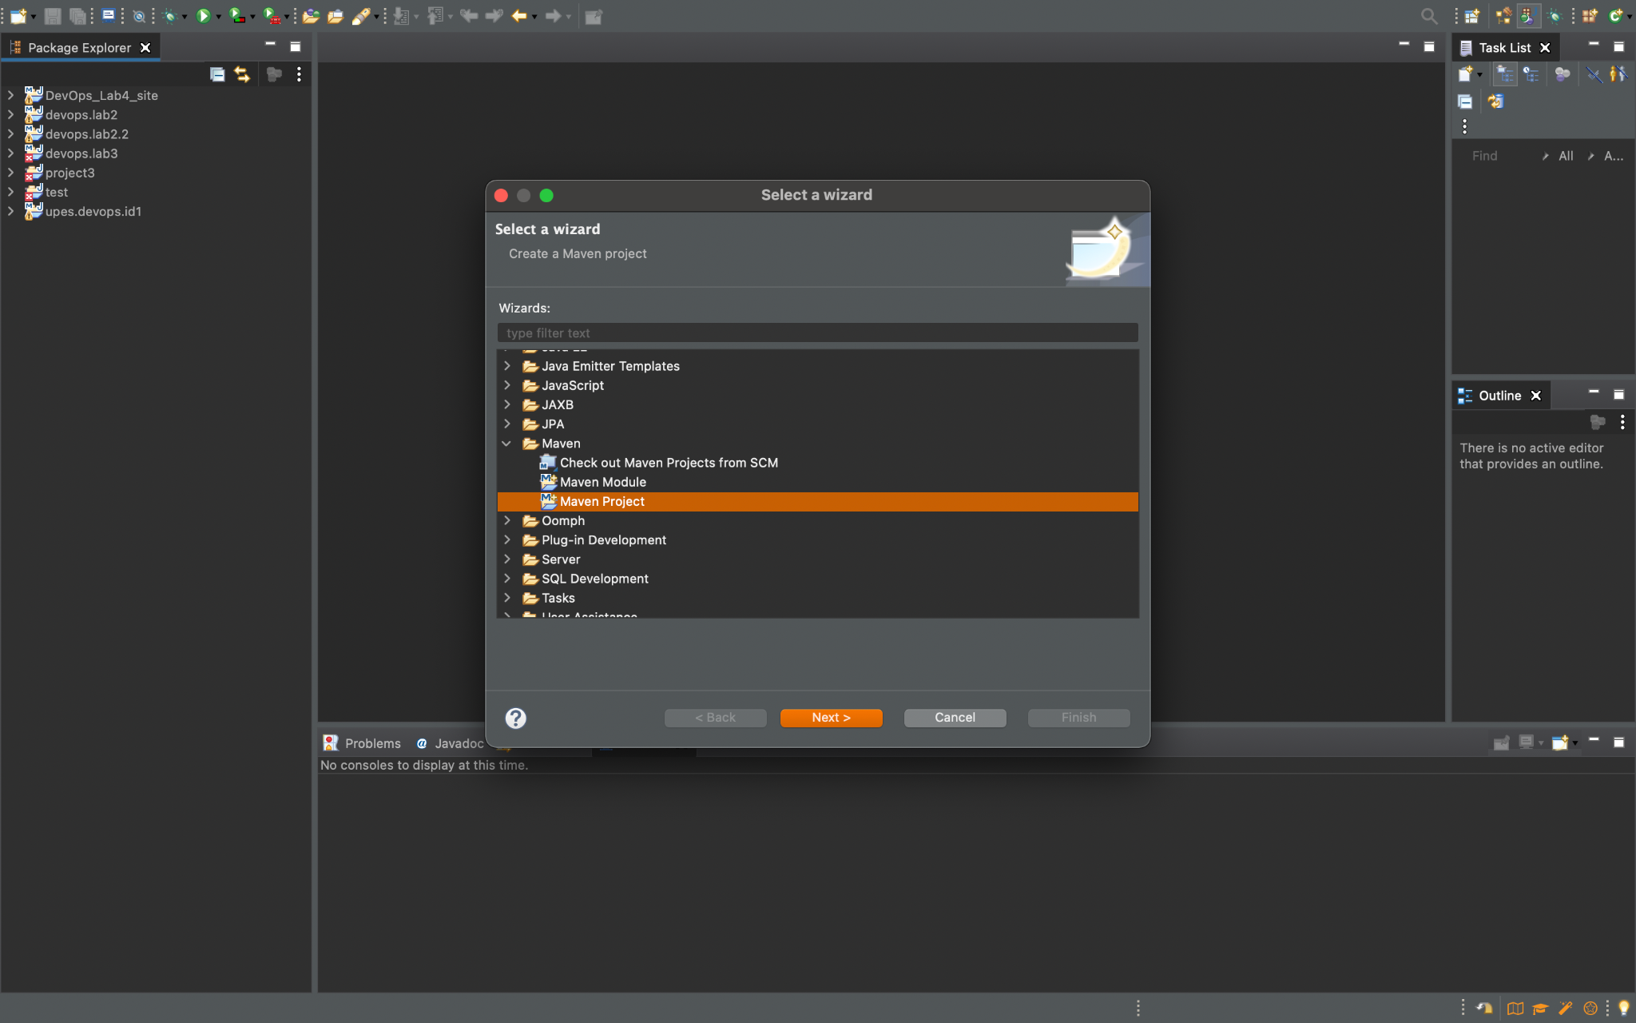

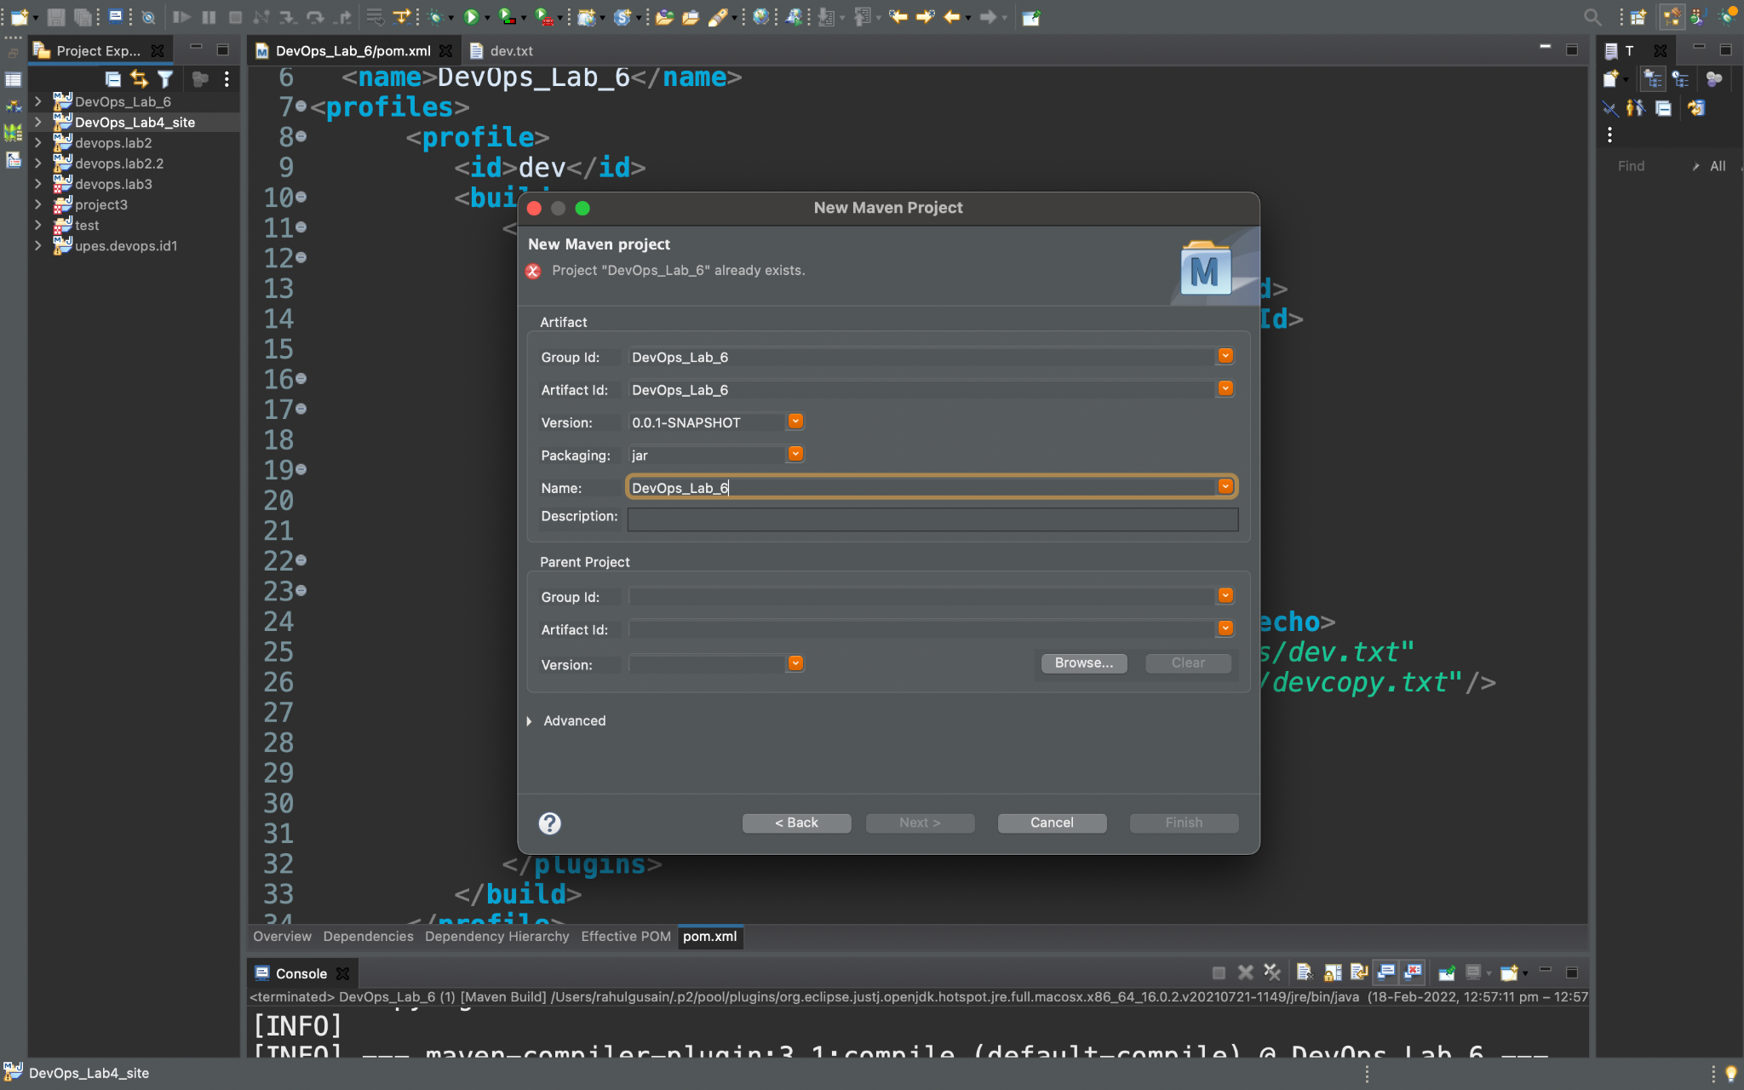

**Step 2:** Create a new text file named dev.txt and prod.txt in the src/main/resources package under the project. Enter “Hello we are in Dev environment” and “Hello we are Prod environment” respectively. Also, design a blank file in the src/test/resources package namely devcopy.txt.

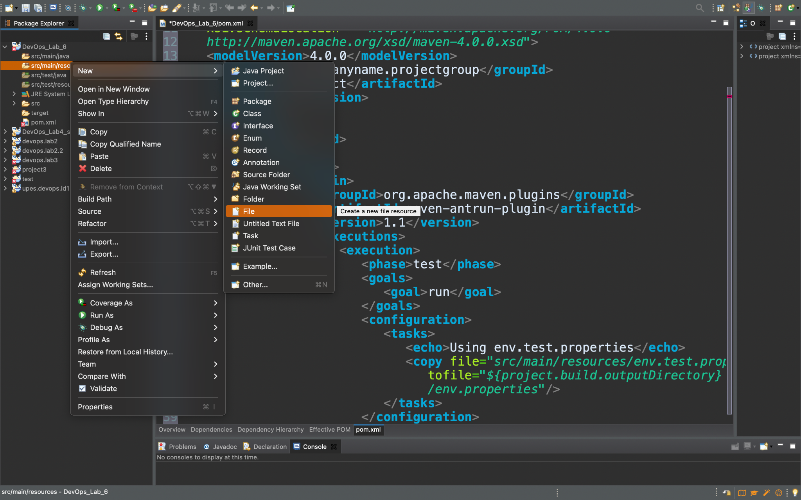

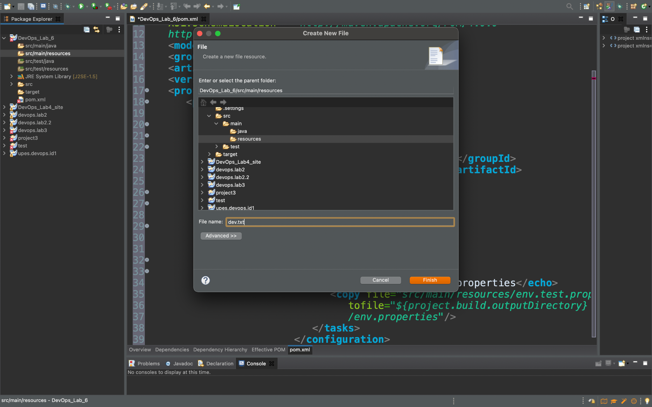

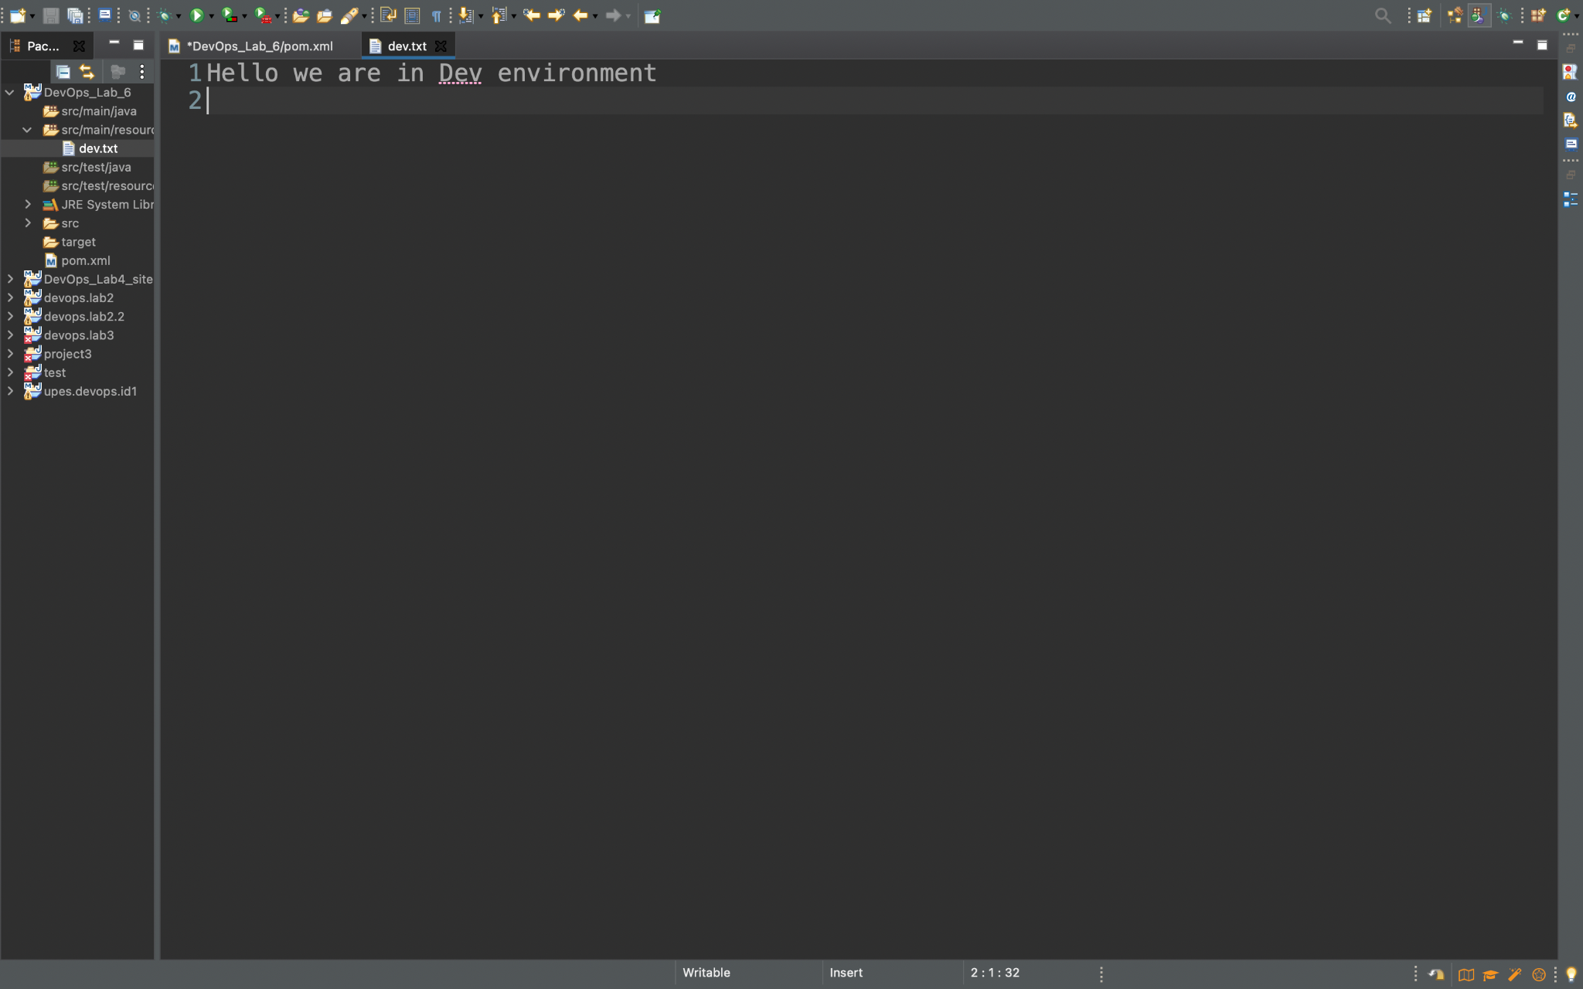

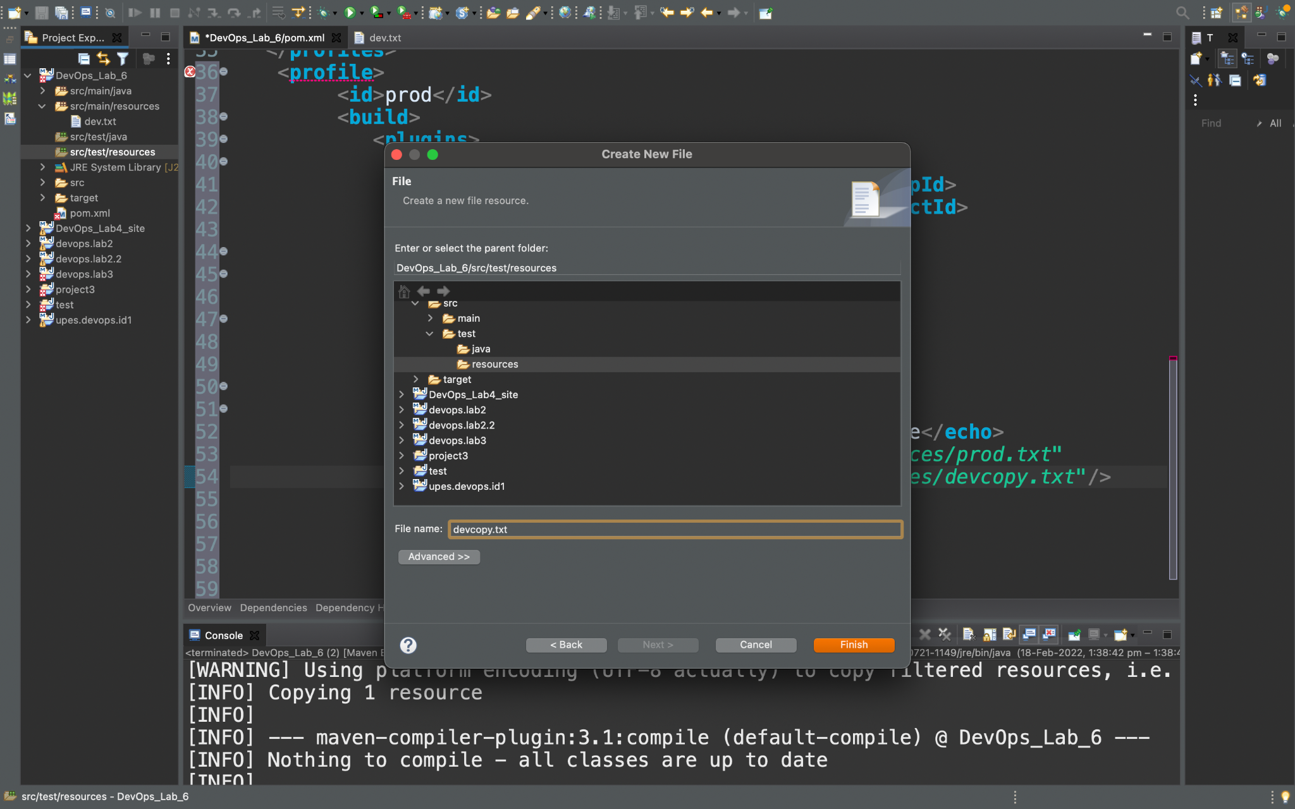

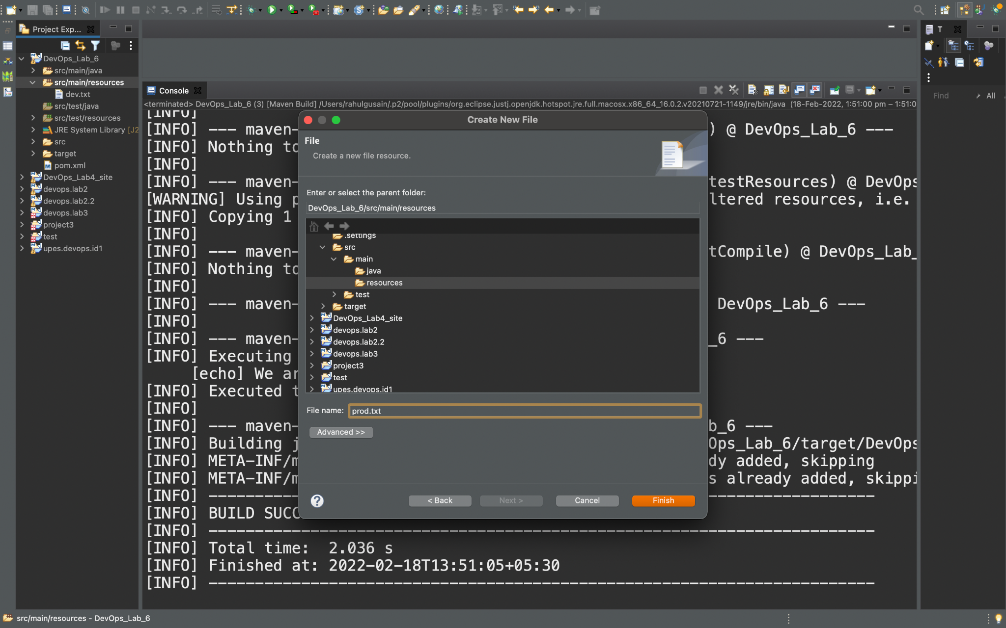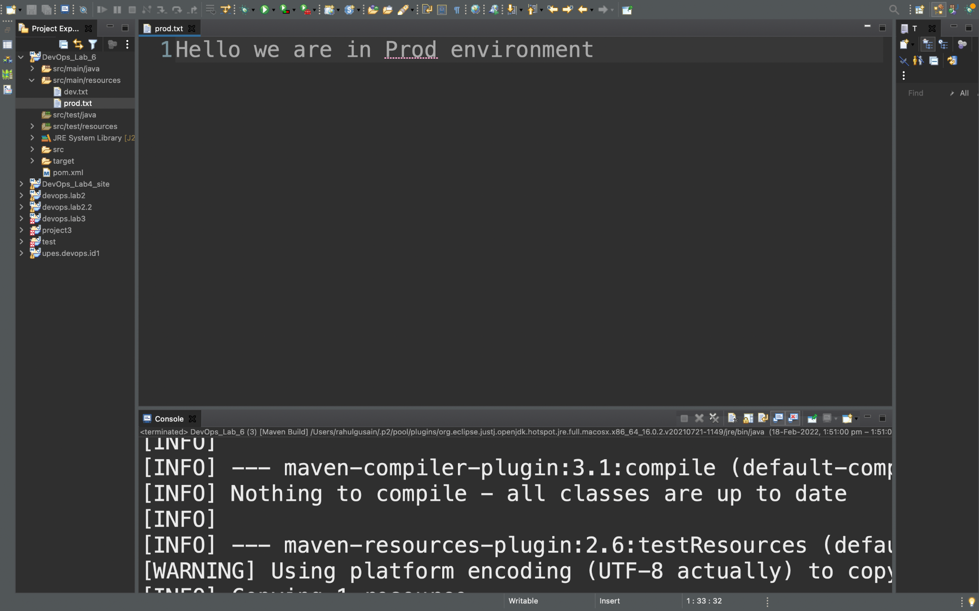

**Step 3:** Open the pom.xml file for this project and make the required changes .Create required profiles we will use two profiles namely as dev and prod . Make the changes in the both the profiles accordingly and assign them tasks .

<**profile**>

<**id**>prod</**id**>

<**build**>

<**plugins**>

<**plugin**>

<**groupId**>org.apache.maven.plugins</**groupId**>

<**artifactId**>maven-antrun-plugin</**artifactId**>

<**version**>1.1</**version**>

<**executions**>

<**execution**>

<**phase**>test</**phase**>

<**goals**>

<**goal**>run</**goal**>

</**goals**>

<**configuration**>

<**tasks**>

<**echo**>We are in Prod Profile</**echo**>

<**copy** file=*"src/main/resources/prod.txt"*

tofile=*"src/test/resources/devcopy.txt"*/>

</**tasks**>

</**configuration**>

</**execution**>

</**executions**>

</**plugin**>

</**plugins**>

</**build**>

</**profile**>

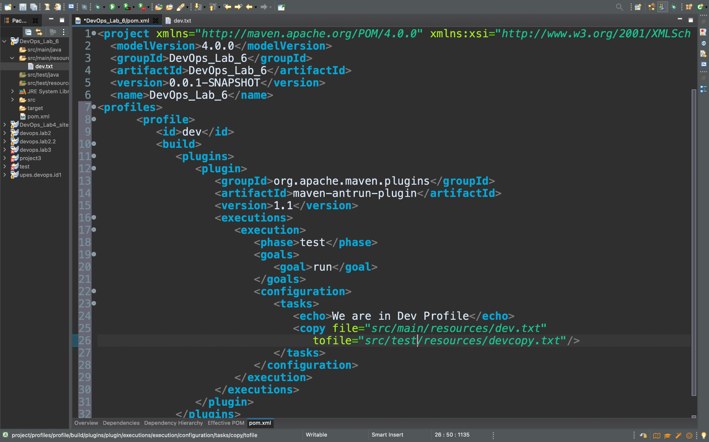

**Step 4:** Run this maven project as the maven build setting the goal as ‘package’ and the profile as ‘dev’.

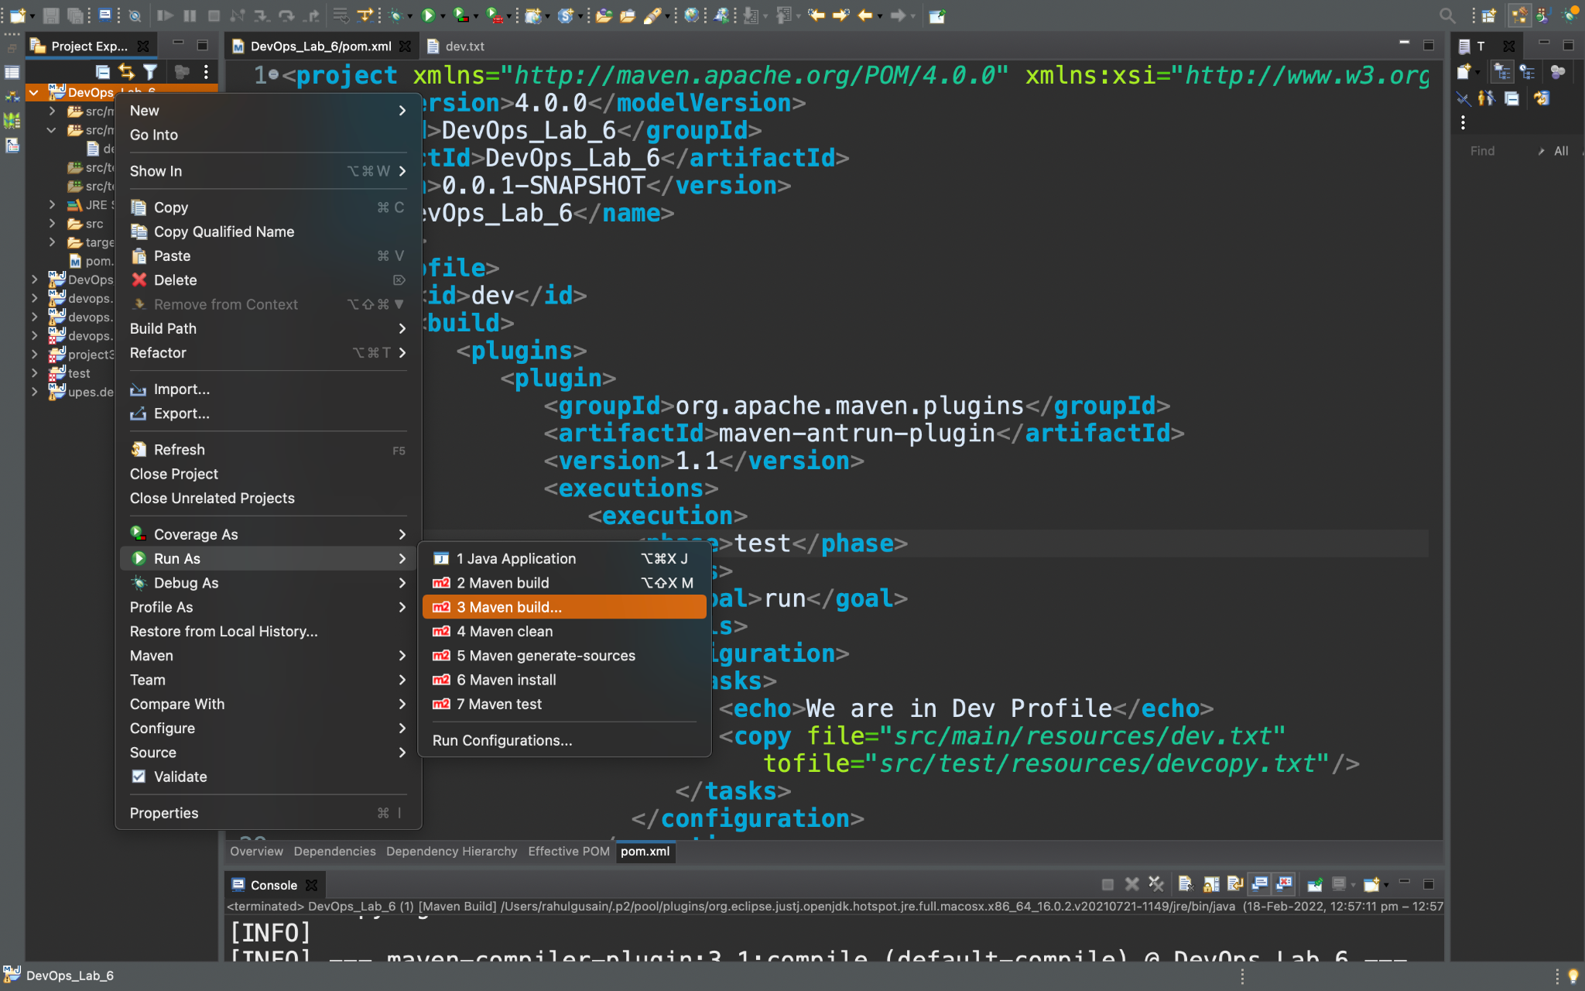

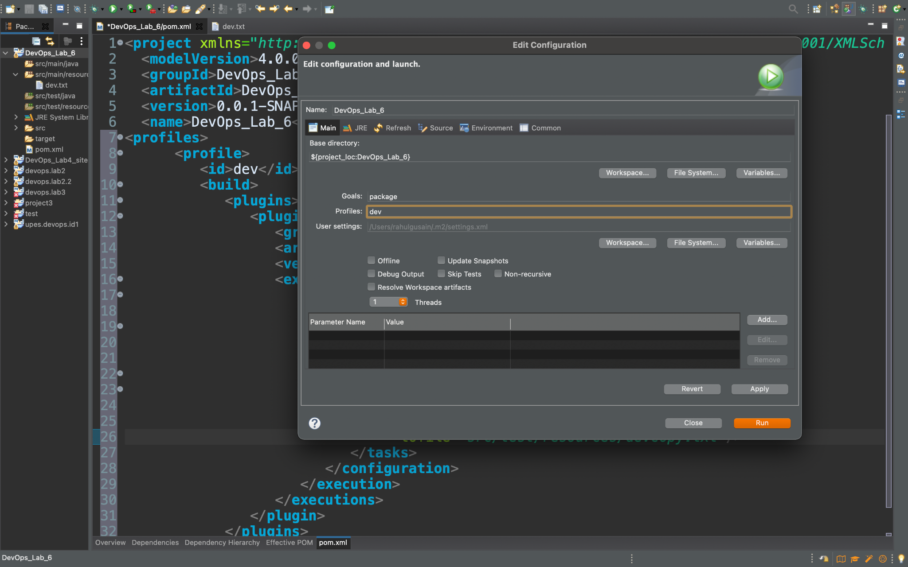

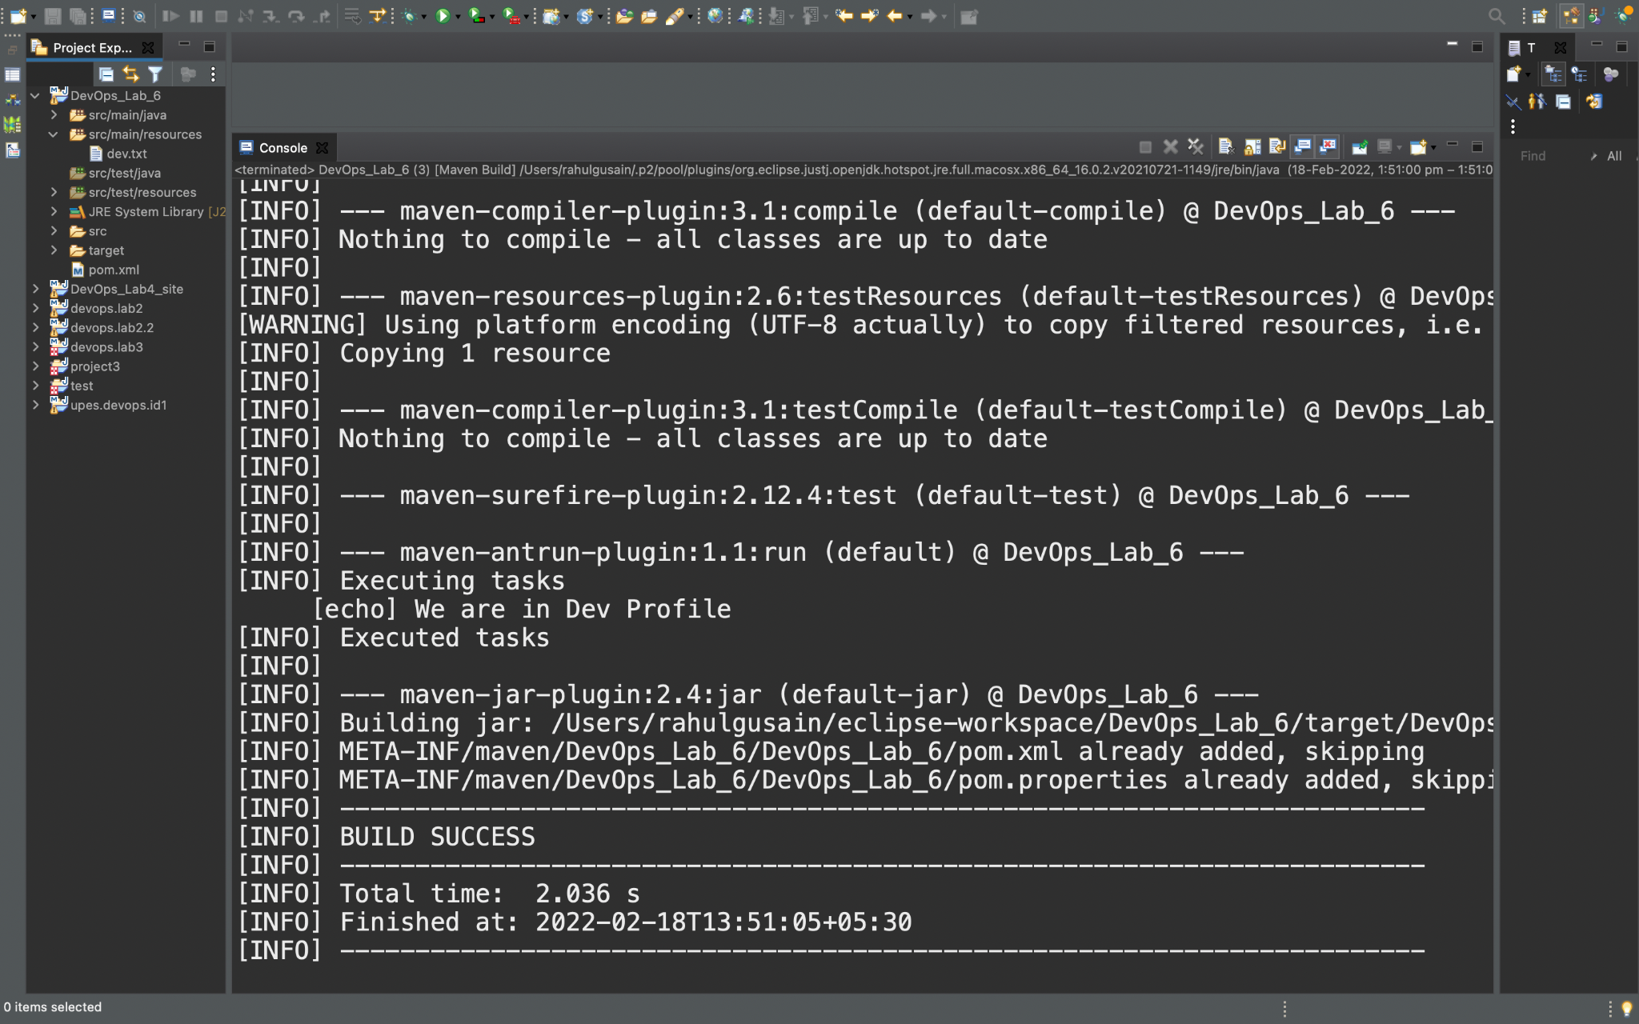 **Step 5:** Check for the copied file in the users folder of the eclipse workspace. 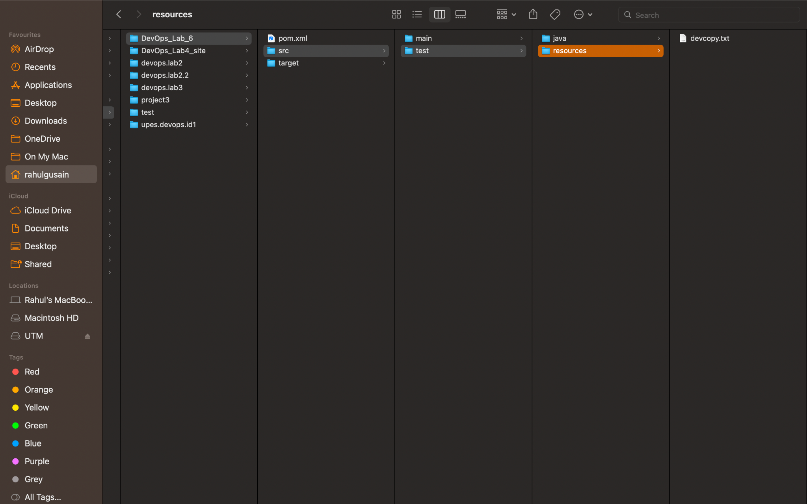

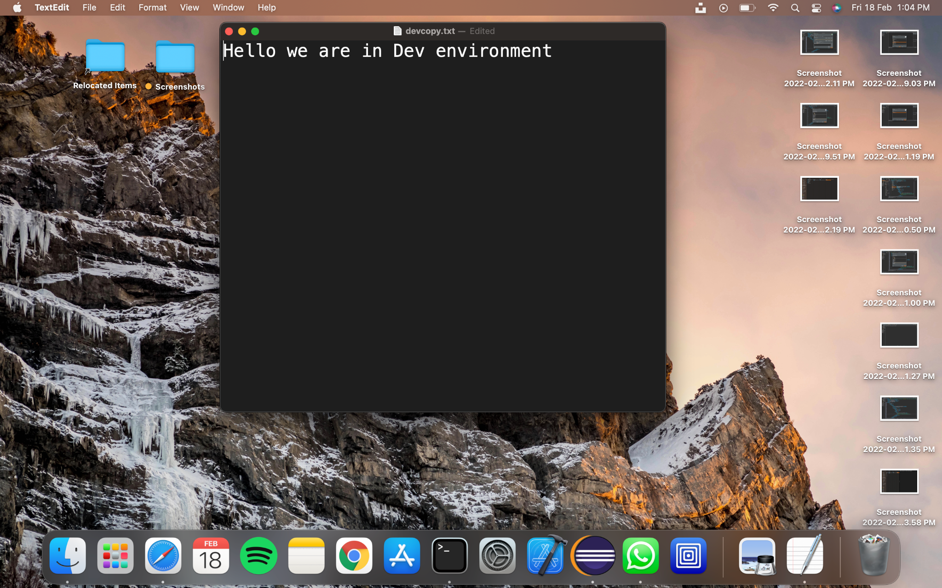

**Step 6:** Run this maven project as the maven build setting the goal as ‘package’ and the profile as ‘prod’.This time setting the profile in the configuration window will set the ‘prod’ profile as the active one.

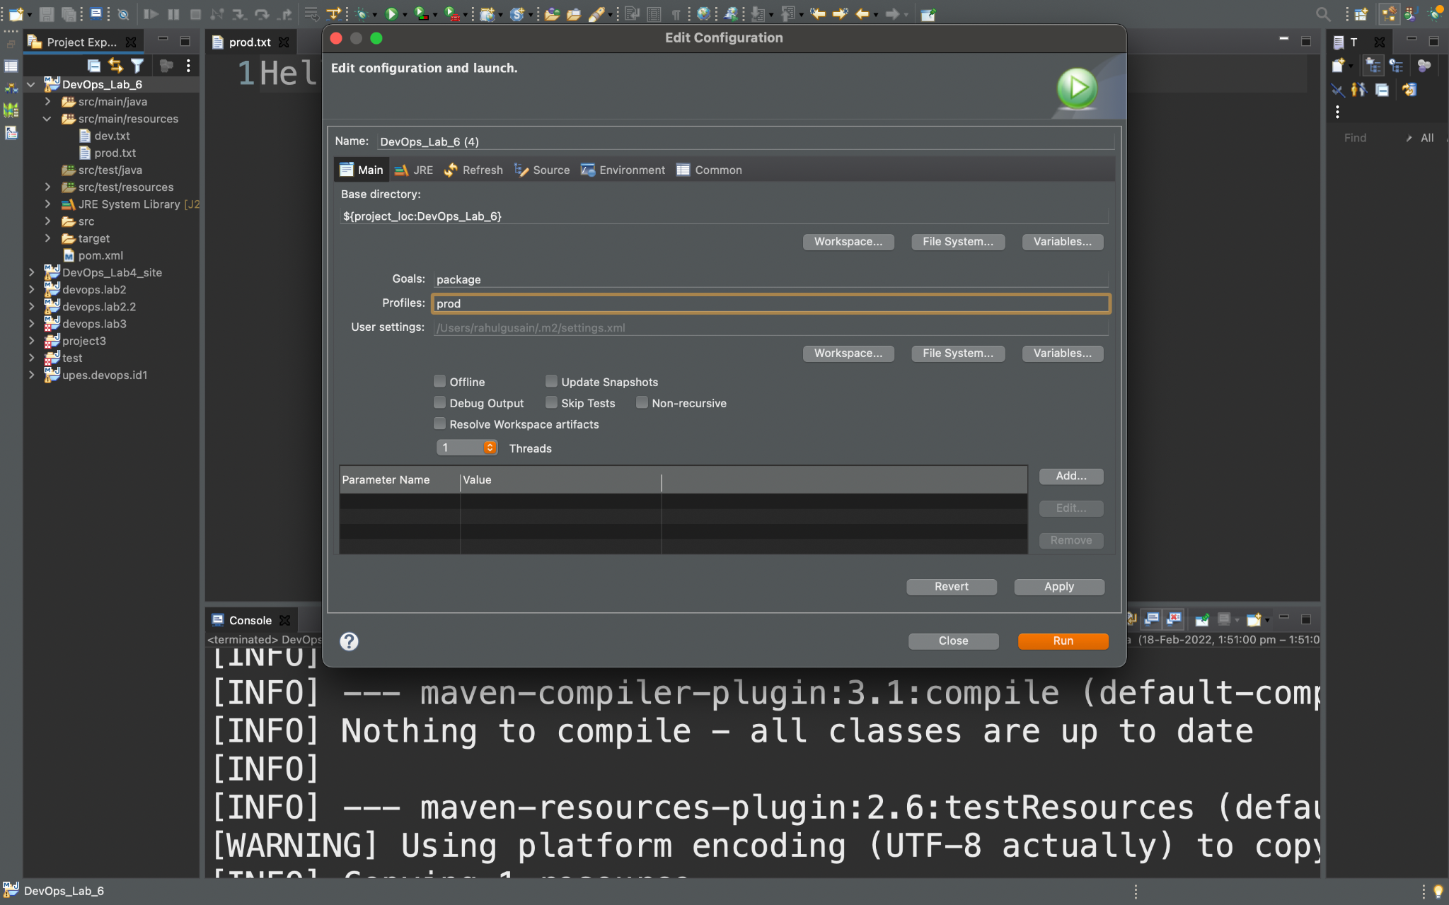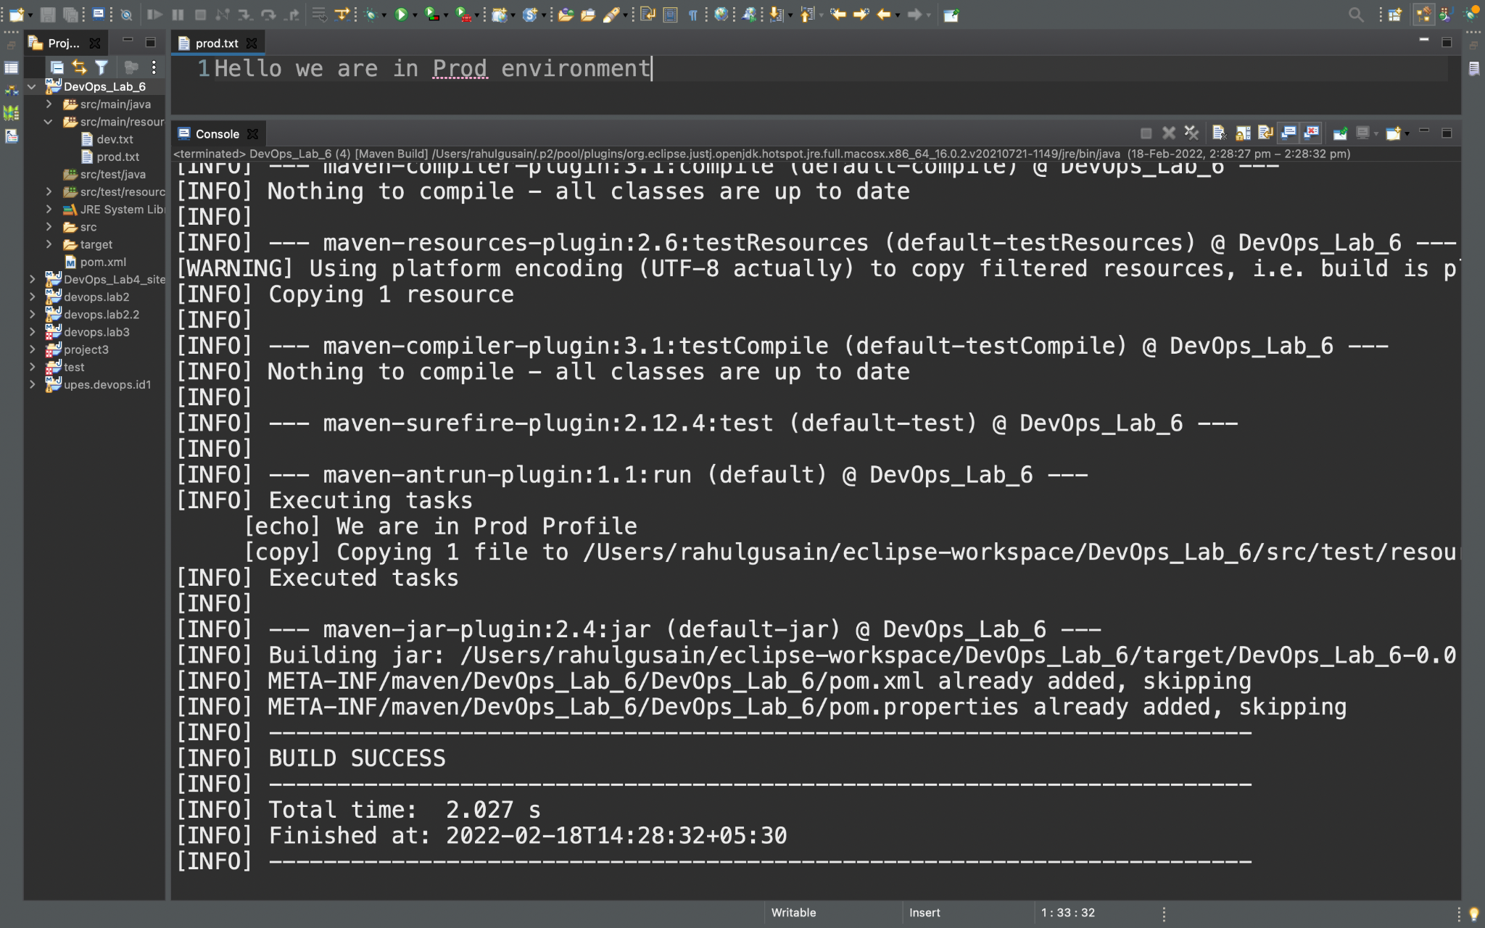

**Step 7:** Check for the copied file in the user’s folder of the eclipse workspace.

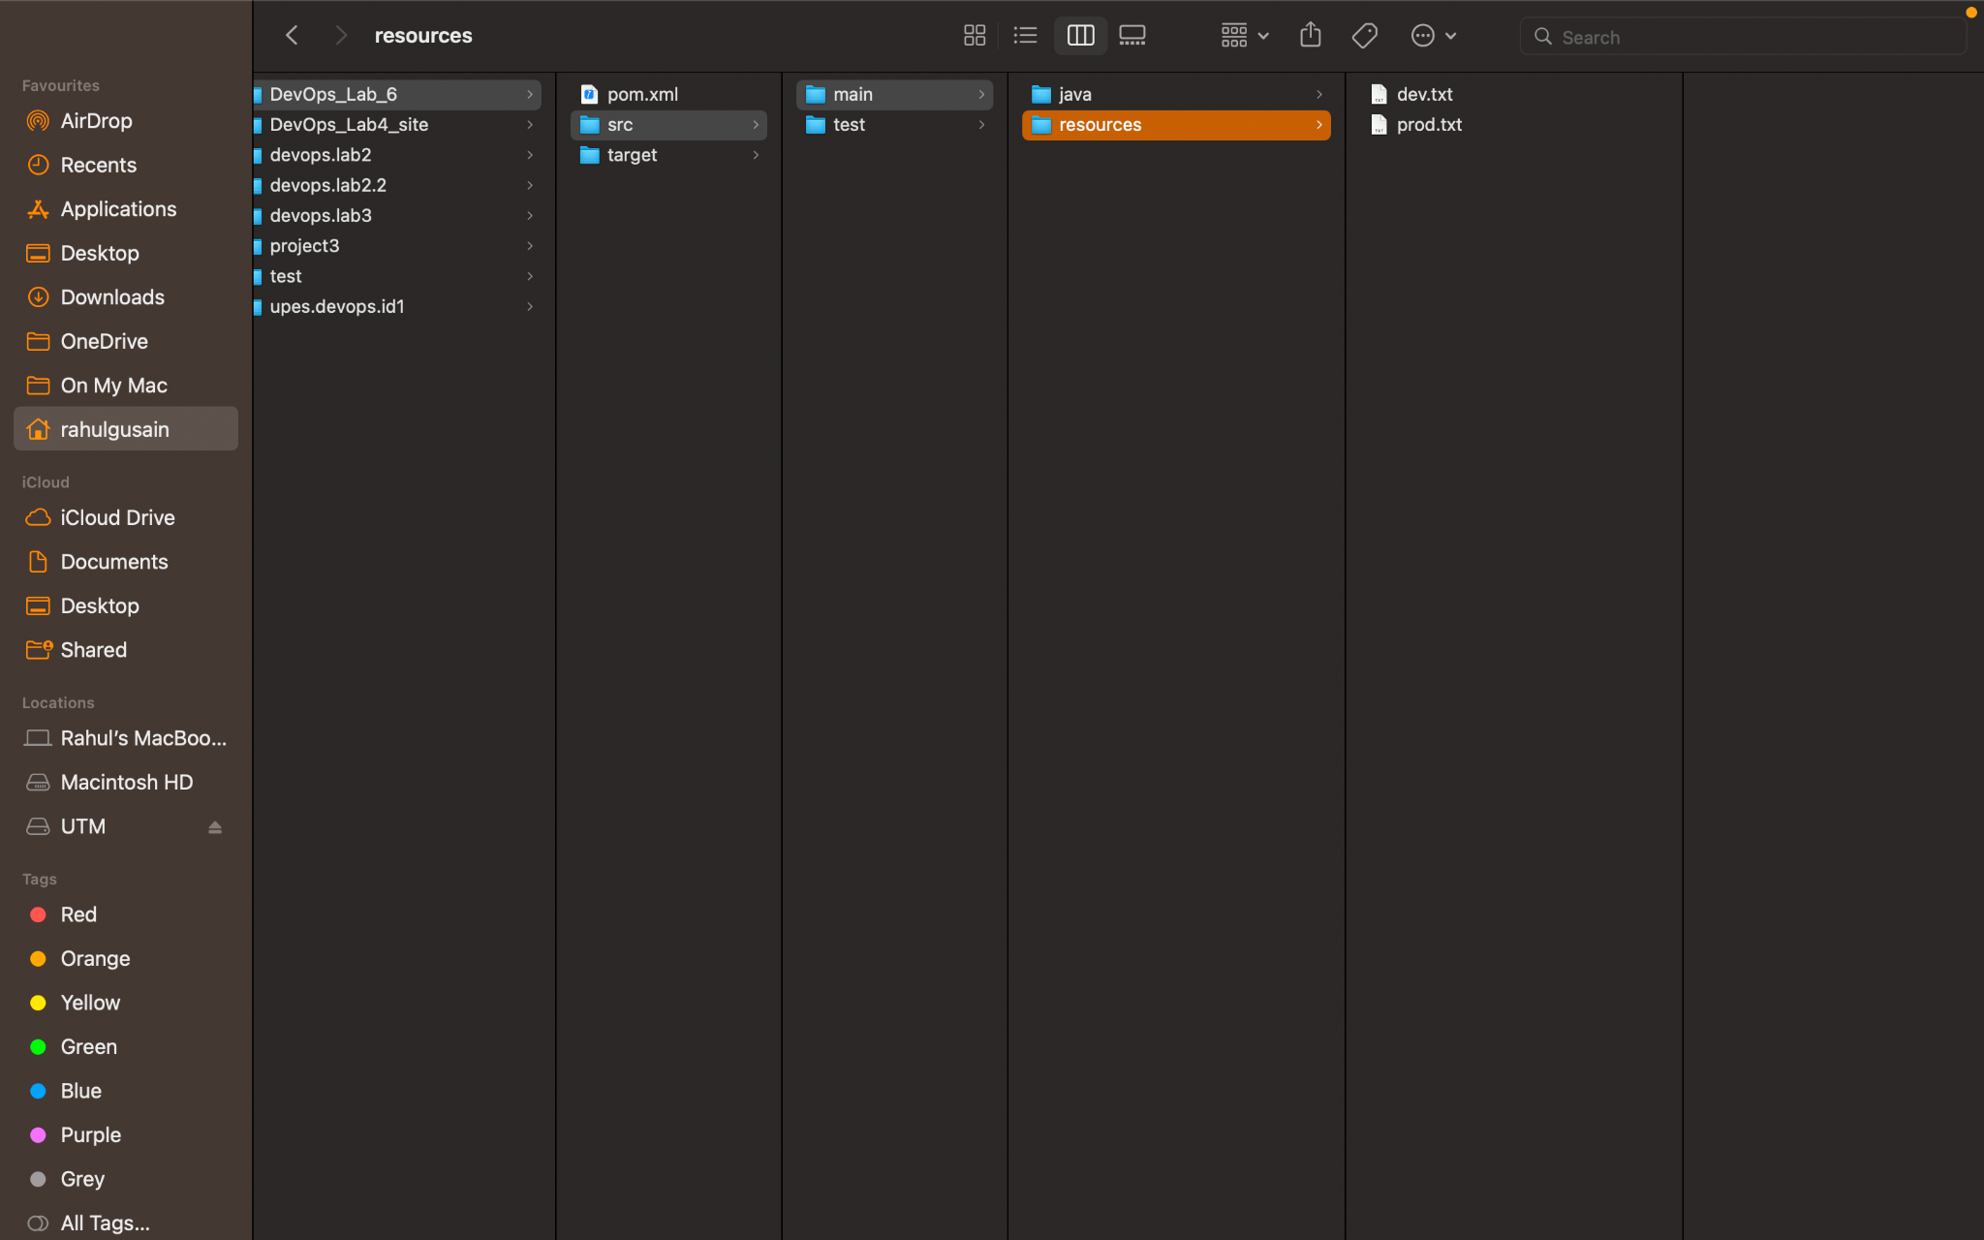

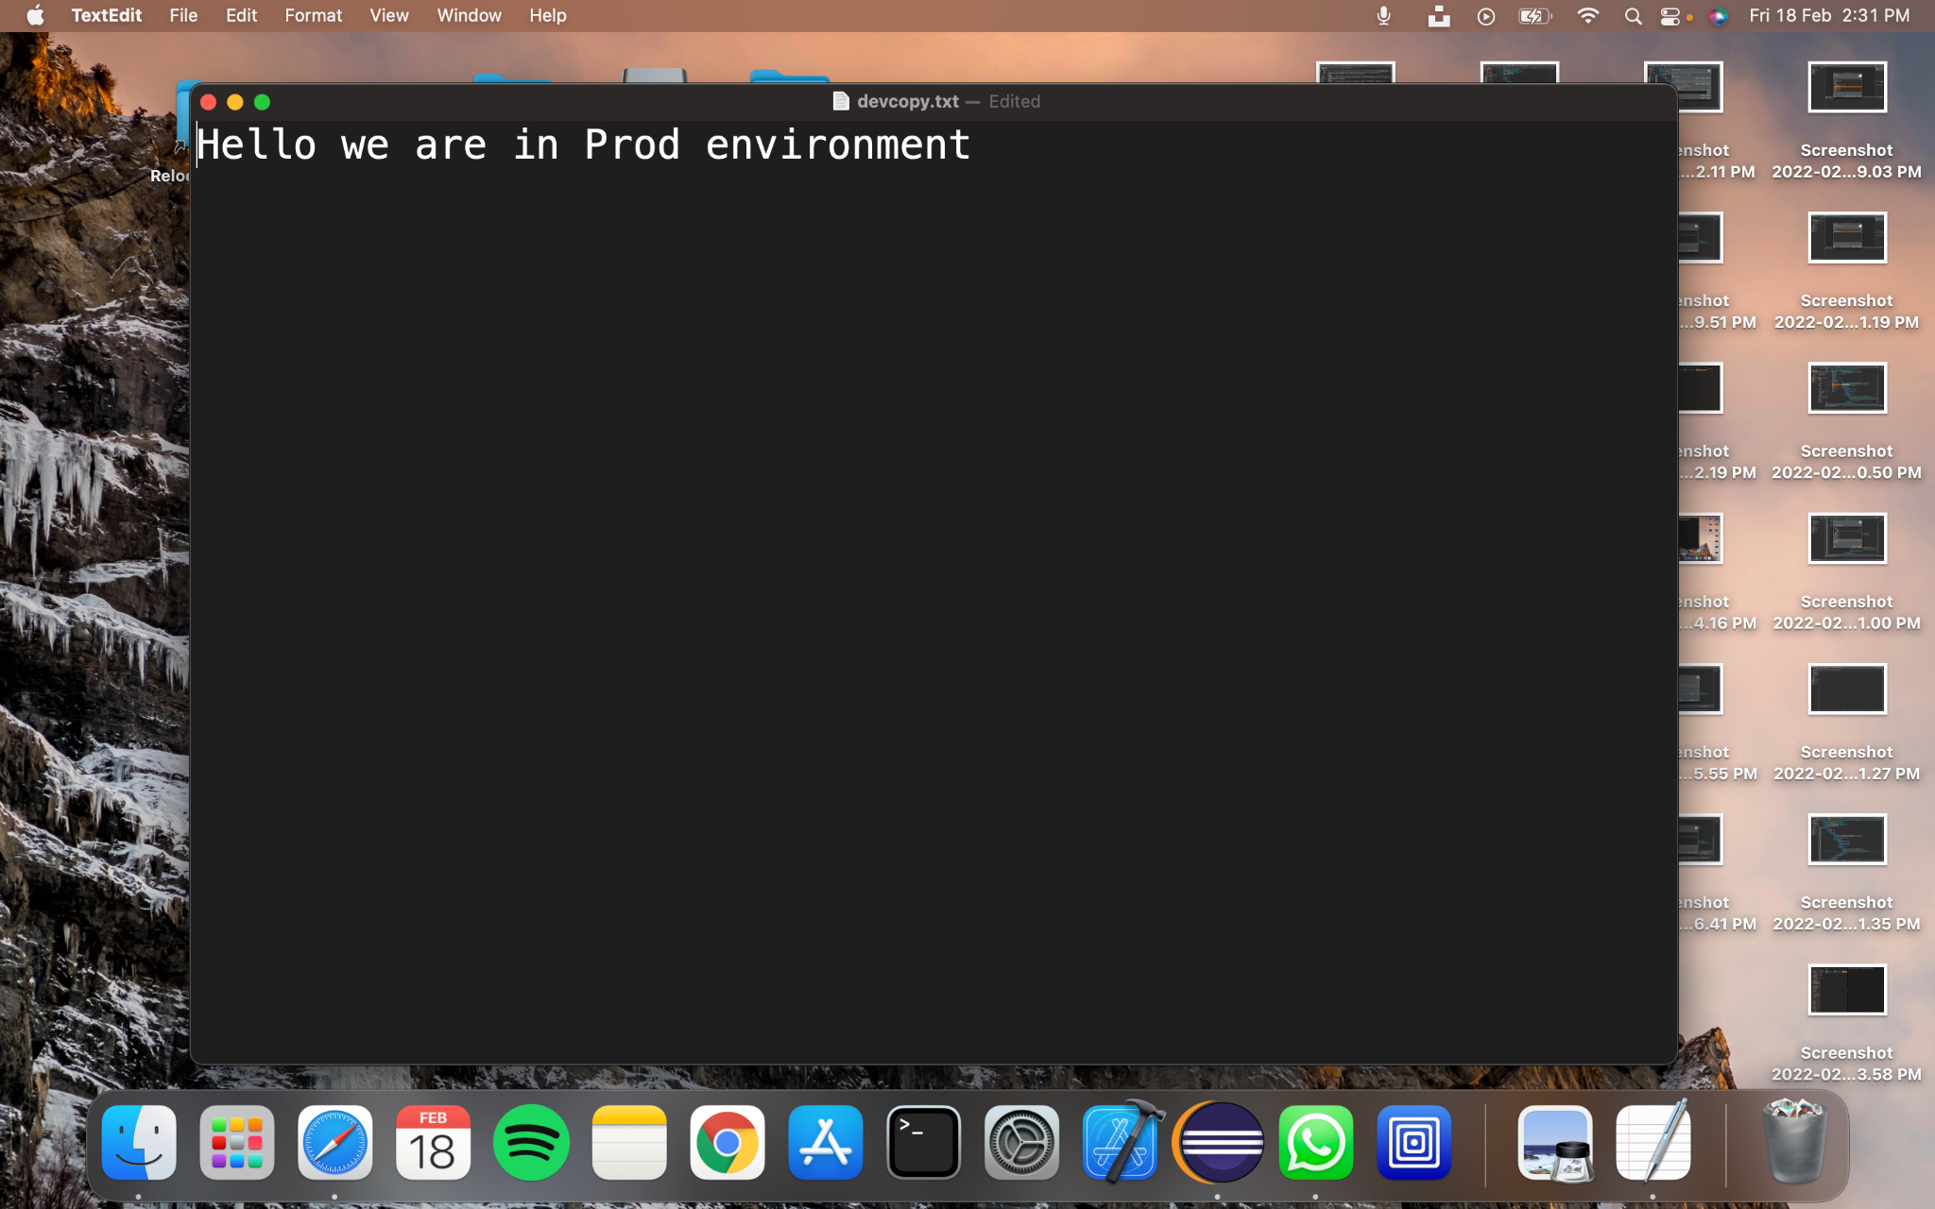

**2)Building profile using CLI.**

**Step 1:** Open the CLI available in your system and check for the maven version using the command mvn –- version.

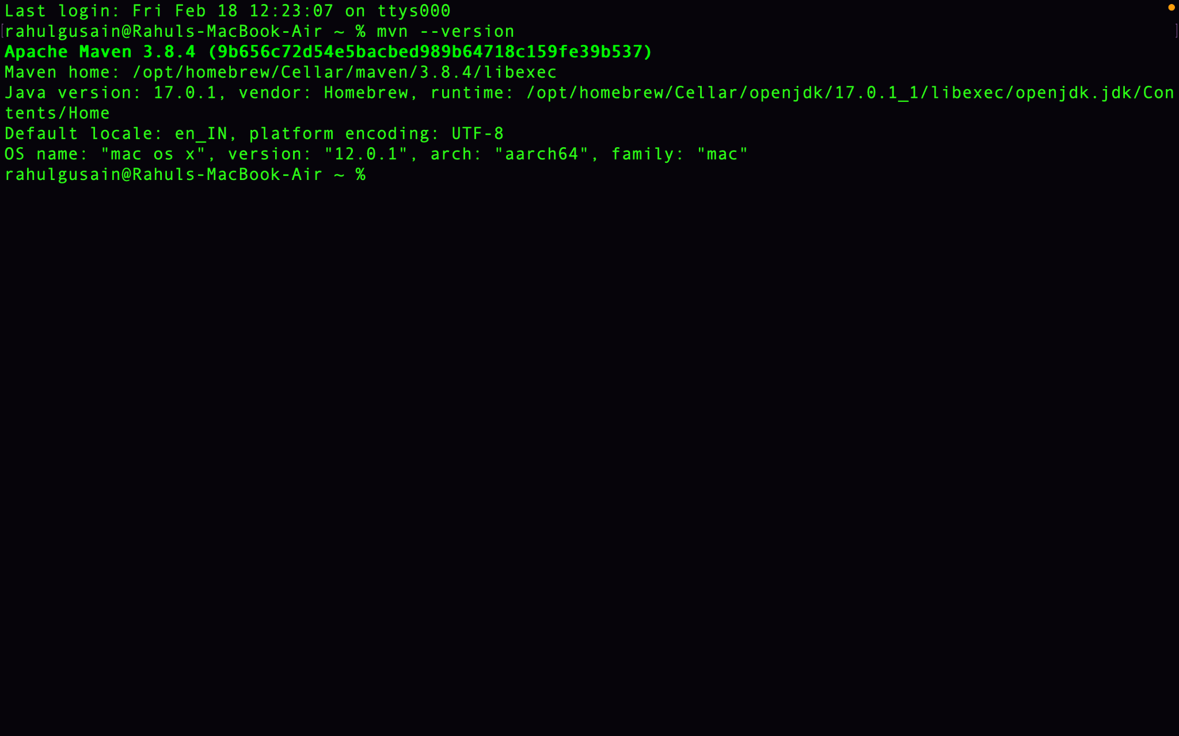We can see that we already have a valid version of maven.

**Step 2:**